Step-by-Step Guide to Troubleshooting GStreamer Errors

Step 1: Check if the GStreamer is working in the environment
The first step is to verify if the webcam is working properly in the system:
Use the following cmd in the terminal:
- gst-launch-1.0 -v ksvideosrc device-index=0 ! videoconvert ! autovideosink
This command should open the webcam of your pc, and changing the number of indexes can also open other devices connected to your pc. You can use it to check if the video streaming of the camera is working

Step 2: Check in the code, to run the properly
Rerun the code, can fix the problem previously found, that the code wasn’t running. If the code doesn’t run, a failure in the installation is found.
If device is streaming wrongly, you can check changing in the code in ‘char *pipeLineString = " -v ksvideosrc device-index=1 ! videoconvert ! autovideosink"’ in the gstreamer_video.cpp in the src folder. A cmake build will be required.

Step-by-Step Guide to alternative solution streaming live pictures of the camera

All the changes were made directly to the main.py and ptw_sony_camera.py files. Here is a proposal of what must be checked and fixed. Suggestions about the solution were proposed in the script.

Step 1: Check if the command to control the RemoteCli.exe
Here was made a new function that try to shut the picture using the LivePreview functionality of the RemoteCli program.
The function proposed is:
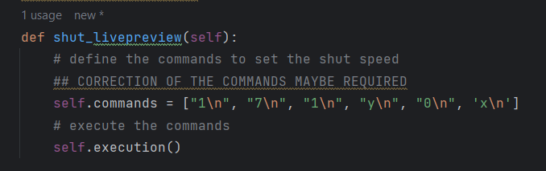

The commands must be checked to see if the commands in the RemoteCli are exactly that to reproduce and then to shut the picture.

Step 2: Check if the algorithm proposed after the LivePreview is made
The following algorithm was proposed to get the image shuttered by LivePreview:
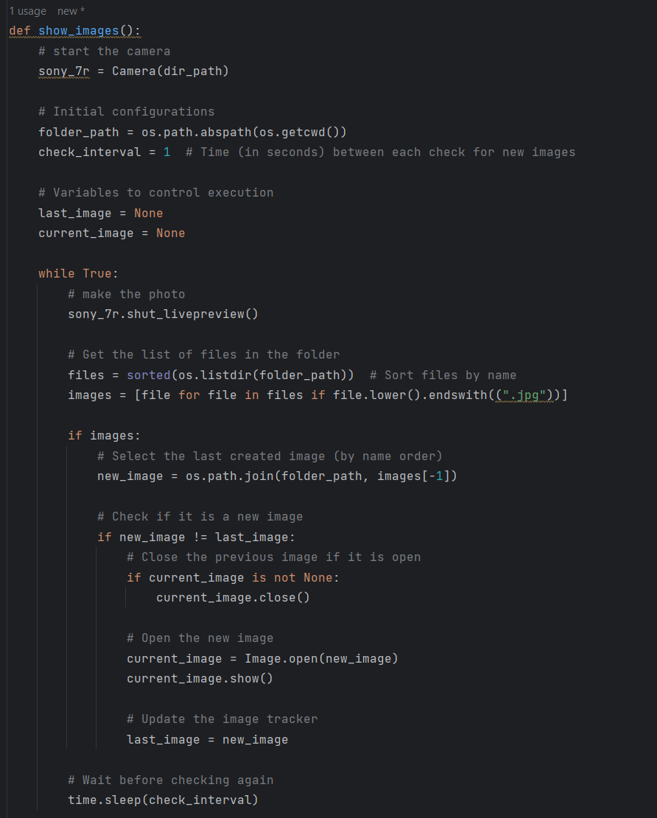
First, the algorithm initializes the camera and then enters the loop. In the loop, it first shuts the picture using the control center of the camera. Then it sorts all files .jpg available in the folder and then gets the filename with the higher number (the newest) because the names are “LivePreview_NUMBER.jpg”. Then the algorithm is quite simple, it erases the older one, then starts the new one and the older one turns into the new one. There is a sleep timer at the end to control how much time it waits.
This function is recursive in the code, which means that it is called every time, so it runs in parallel to the other function. Maybe this can be problematic because it can interfere with the function of shutting a photo normally, but it was understood that the RemoteCli doesn’t run in parallel, therefore the two functionalities of the code will happen in series.

